# IPSTCoder Information: True

Test Result: Success

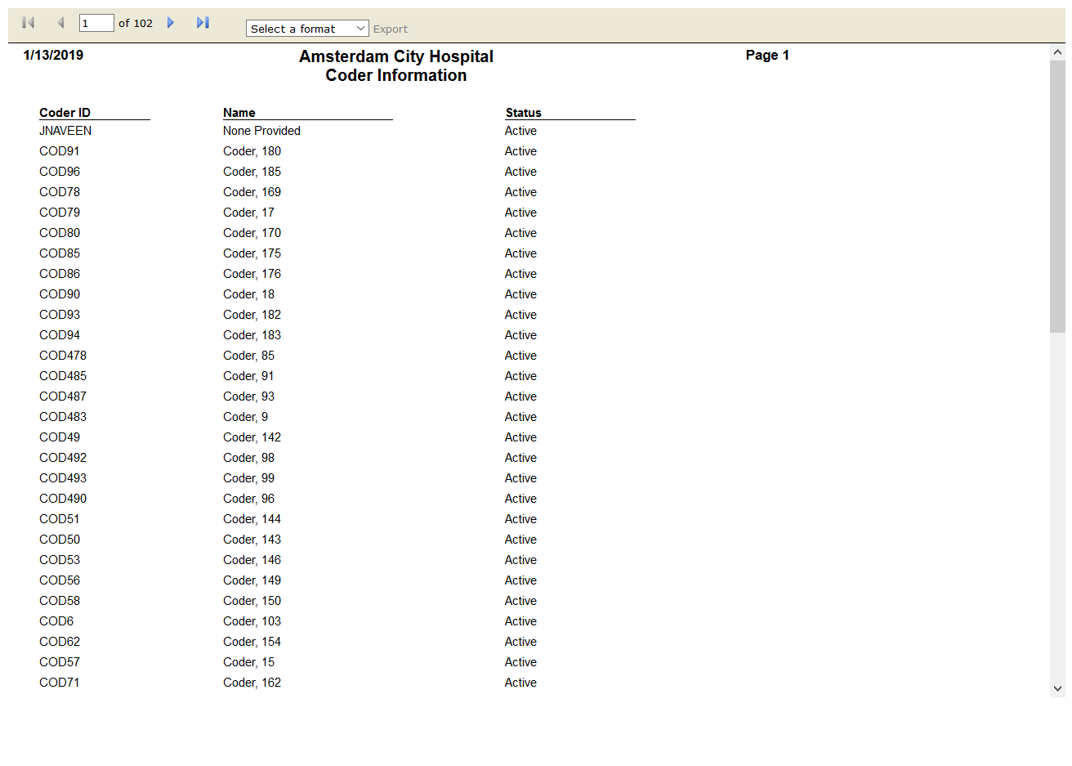

# OPSTFrequency Summary: True

Test Result: Success

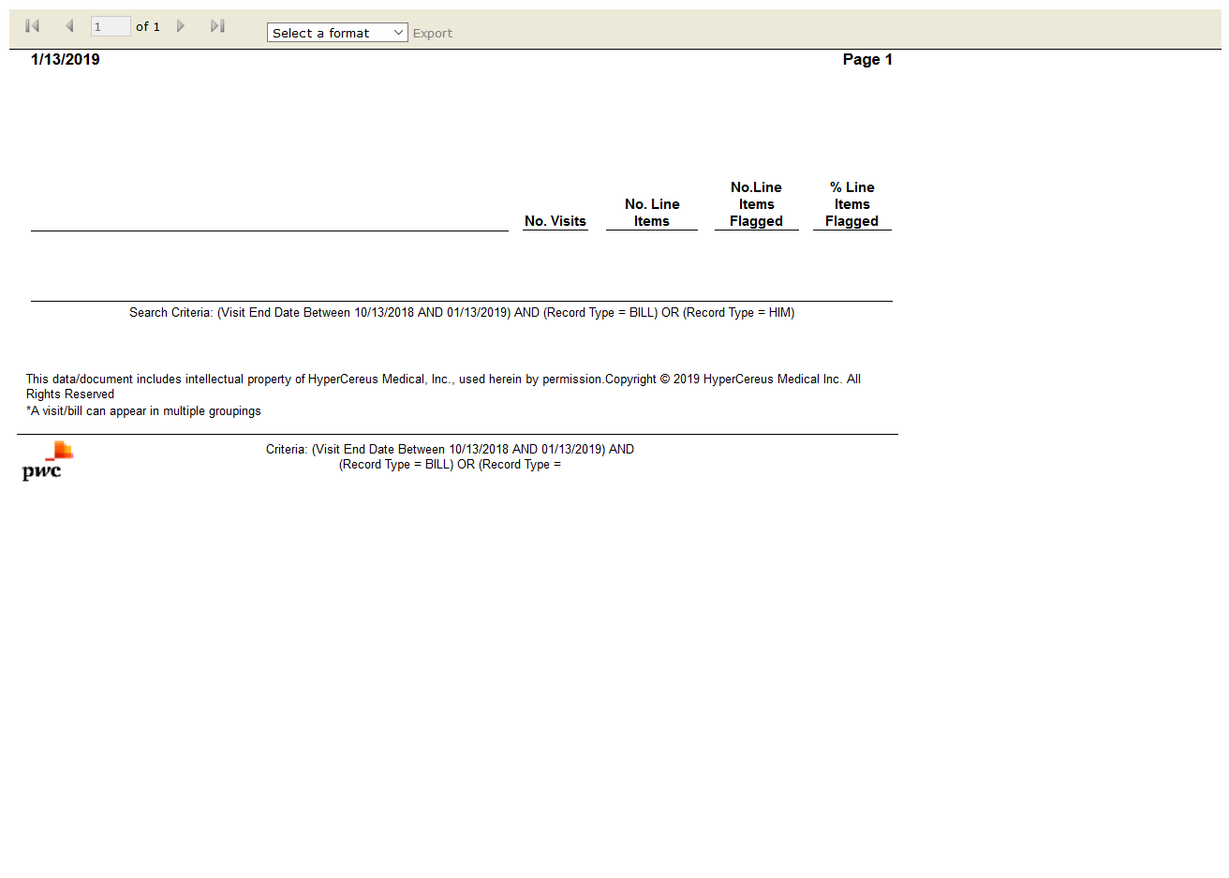

# OPSTReview Worksheet: True

Test Result: Success

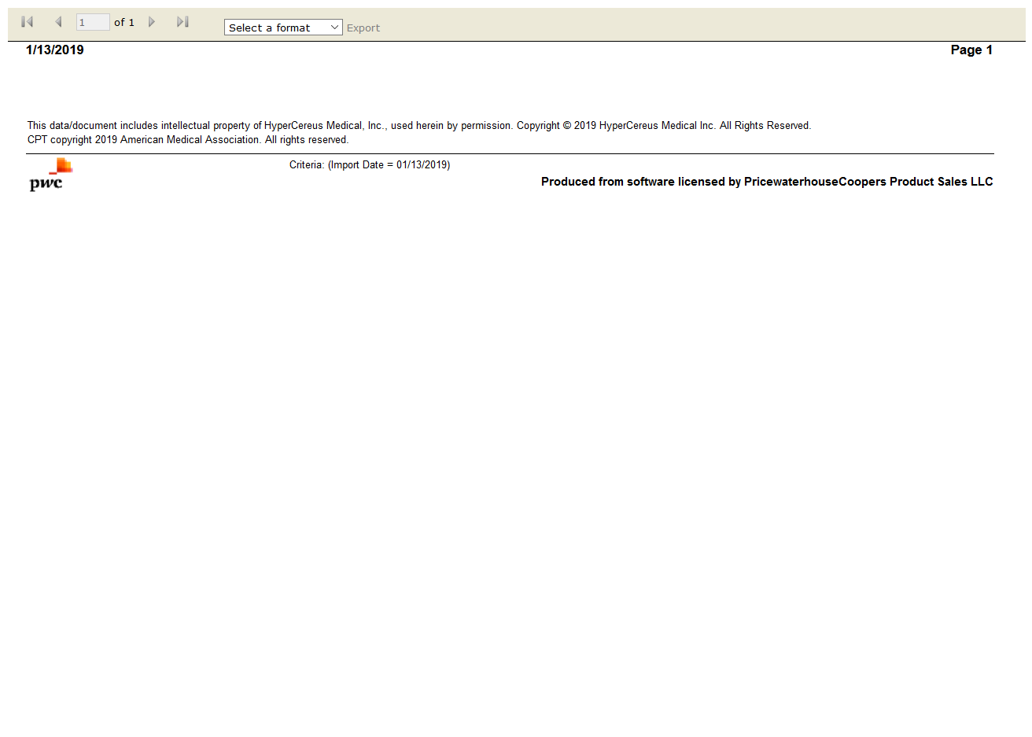

# OPSTVisits Processed on Import: True

Test Result: Success

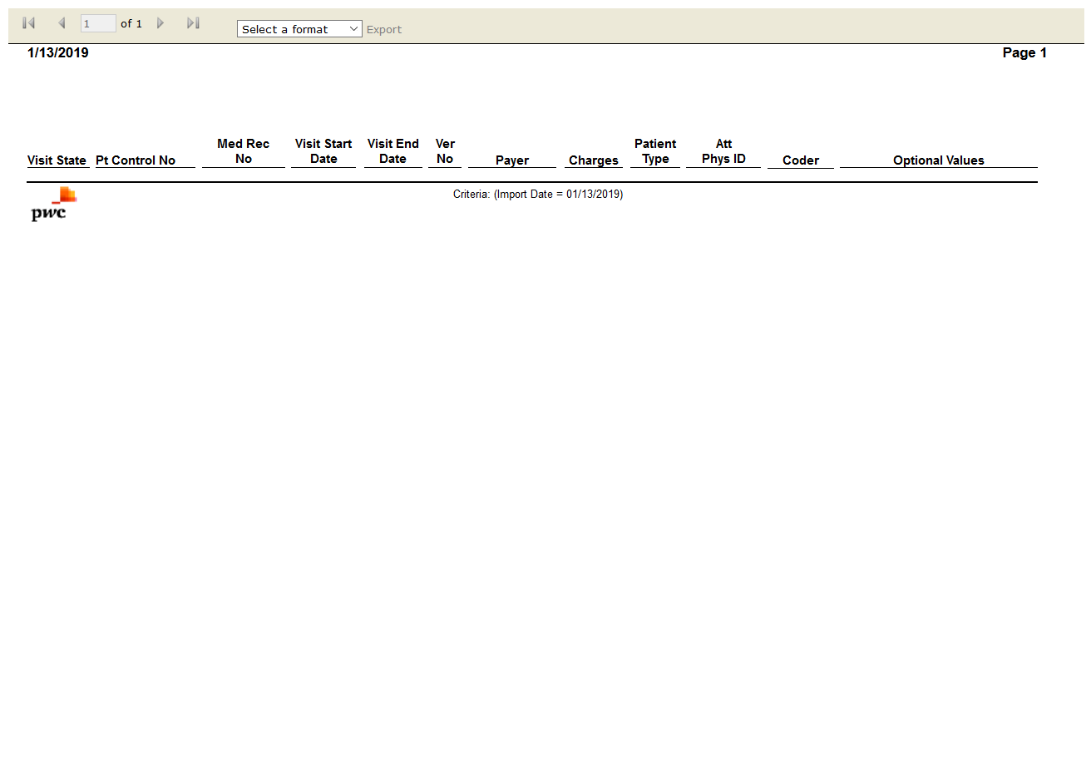

# OPSTCoder Profile: True

Test Result: Success



# OPSTEvaluation & Management Clinical Profile: False

Test Result: Message: Unable to locate element: //span[contains(text(),"Standard Reports")]



# OPSTSMART Results Summary: True

Test Result: Success

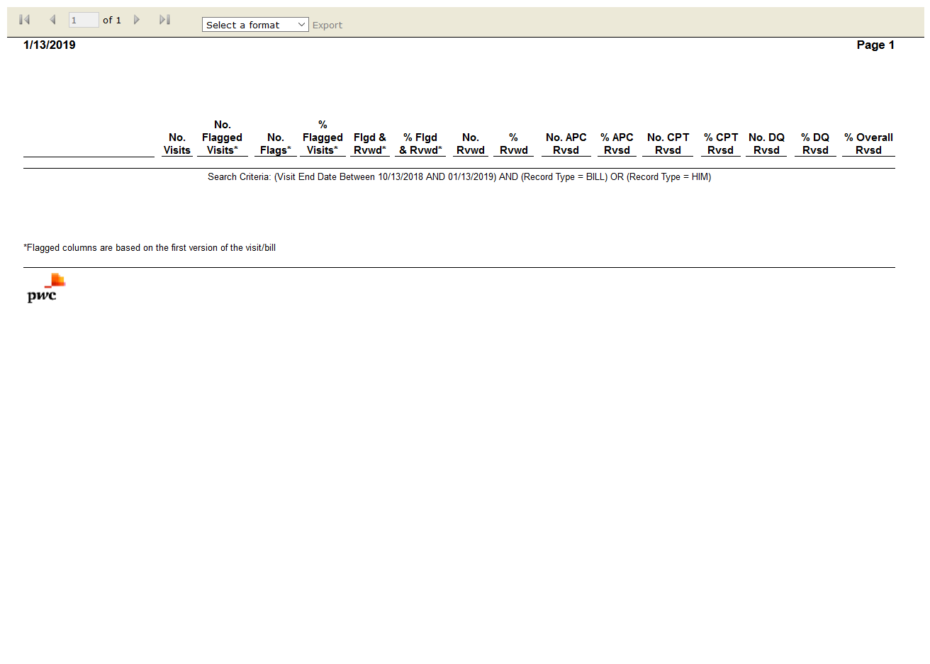

# OPSTVisit Change Results: False

Test Result: Message: Unable to locate element: Visit Change Results

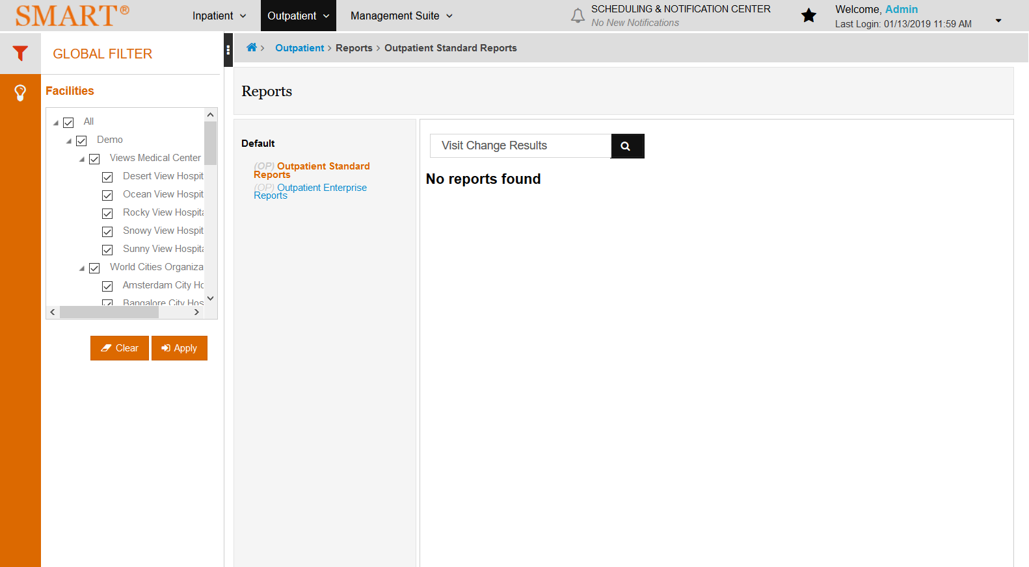

# OPSTVisit Selection Summary: False

Test Result: Message: Unable to locate element: Visit Selection Summary

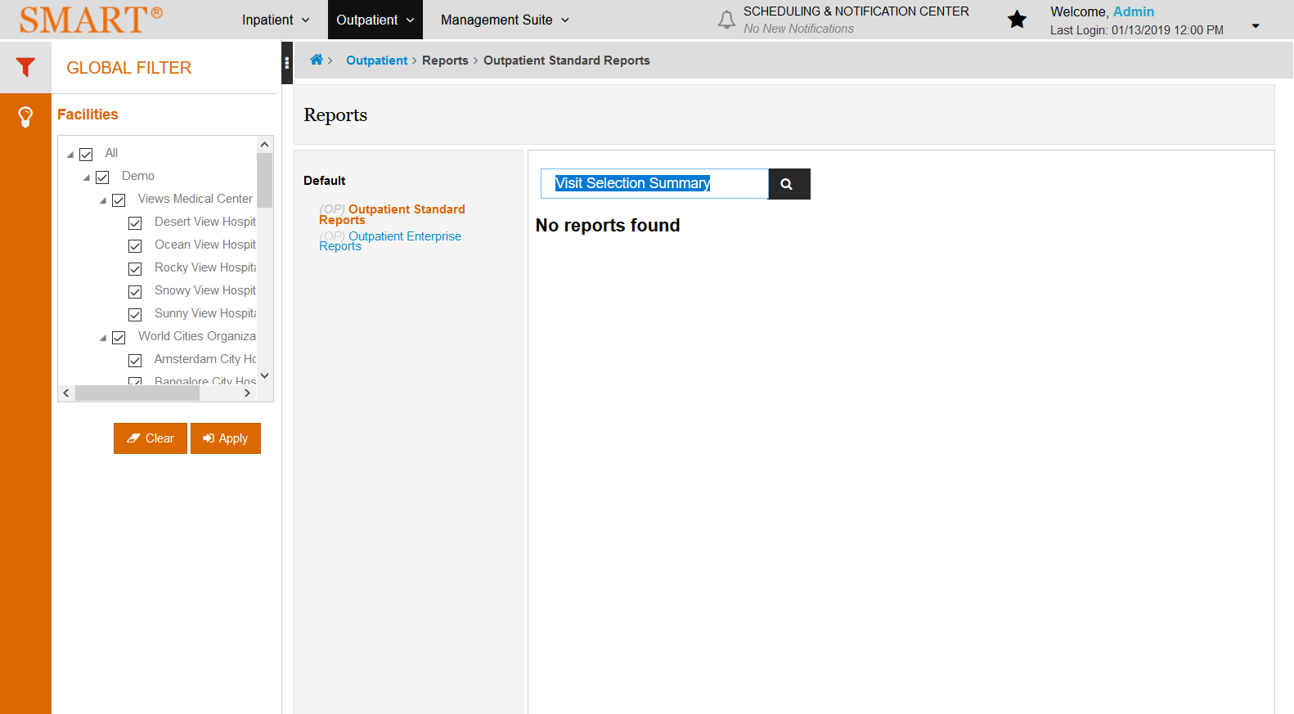

# OPSTVisit Summary: True

Test Result: Success

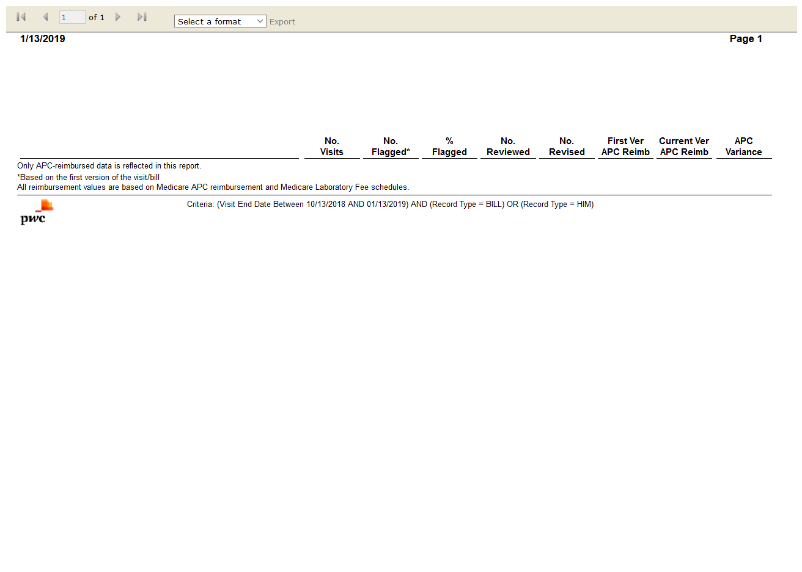

# OPSTAPC Reimbursement Visit Summary: True

Test Result: Success



# IPSTCase Listing: True

Test Result: Success

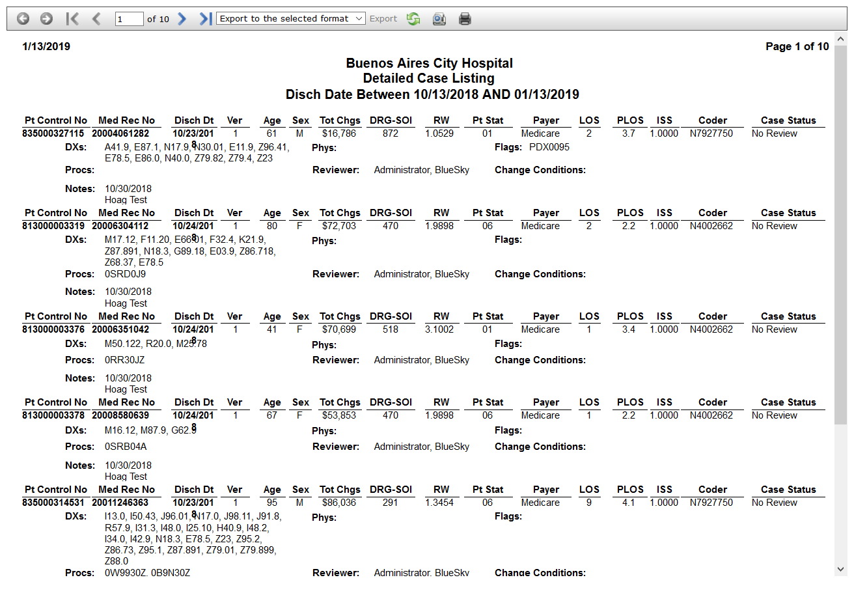

# OPSTDiscrepancy Analysis: True

Test Result: Success

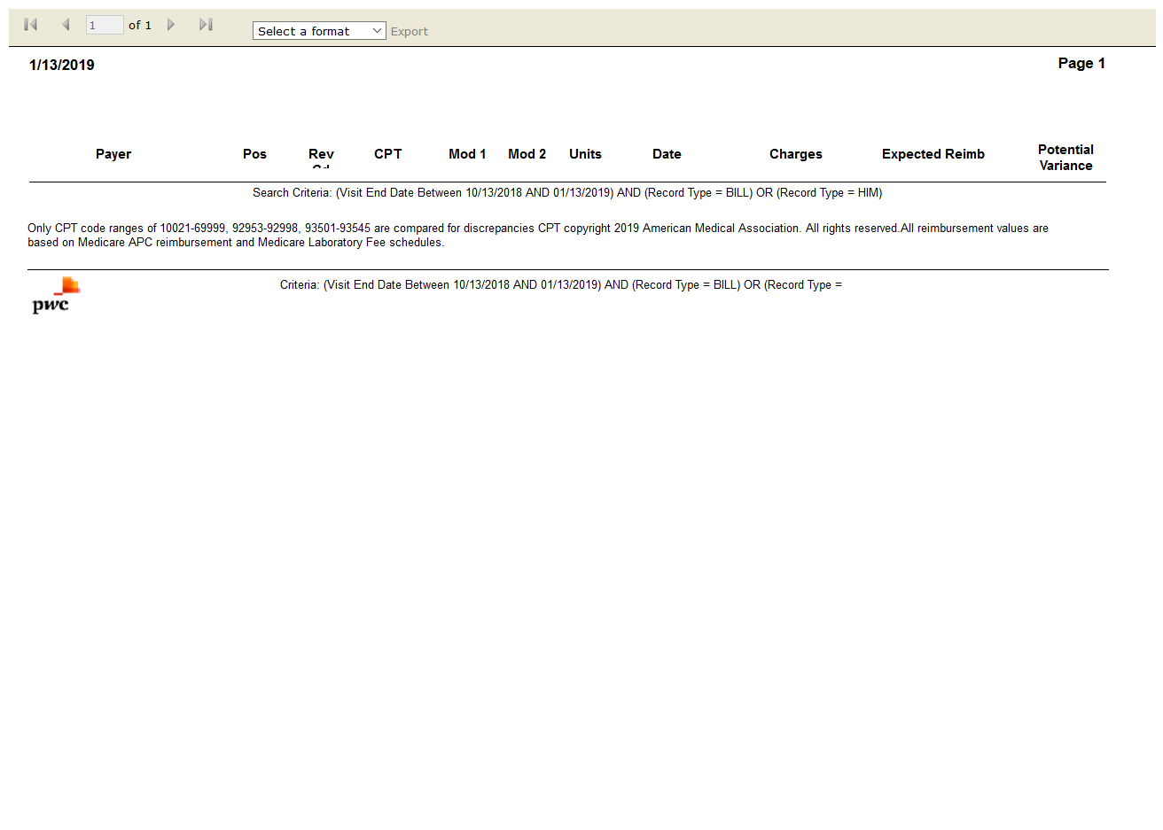

# OPSTEstimated Line Item Reimbursement Impact Summary by Body System: False

Test Result: Message: Unable to locate element: Estimated Line Item Reimbursement Impact Summary by Body System

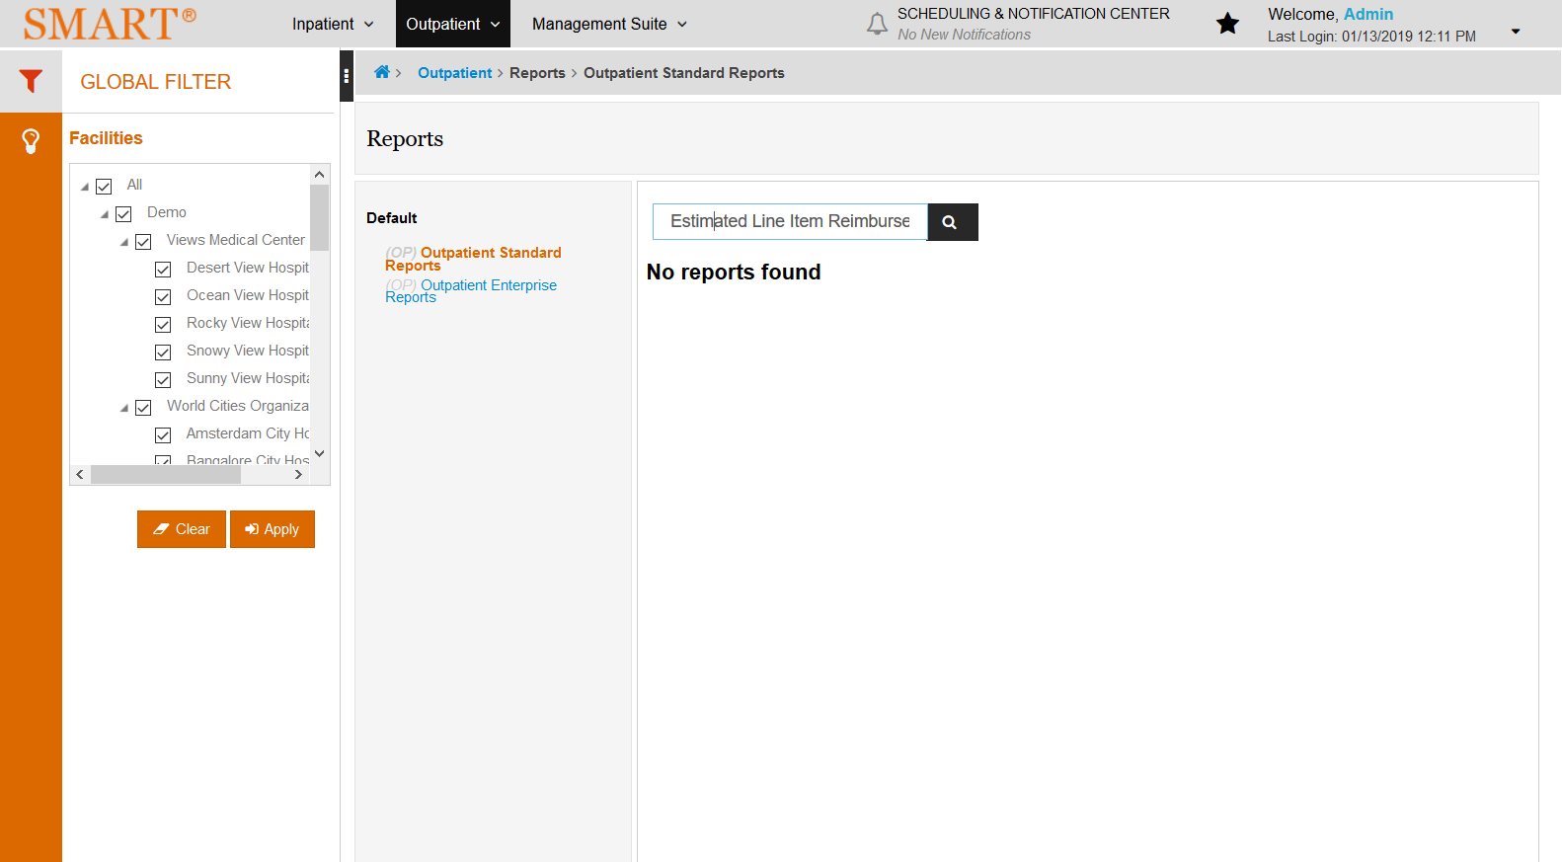

# OPSTEstimated Reimbursement Impact Summary: False

Test Result: Message: Unable to locate element: Estimated Reimbursement Impact Summary

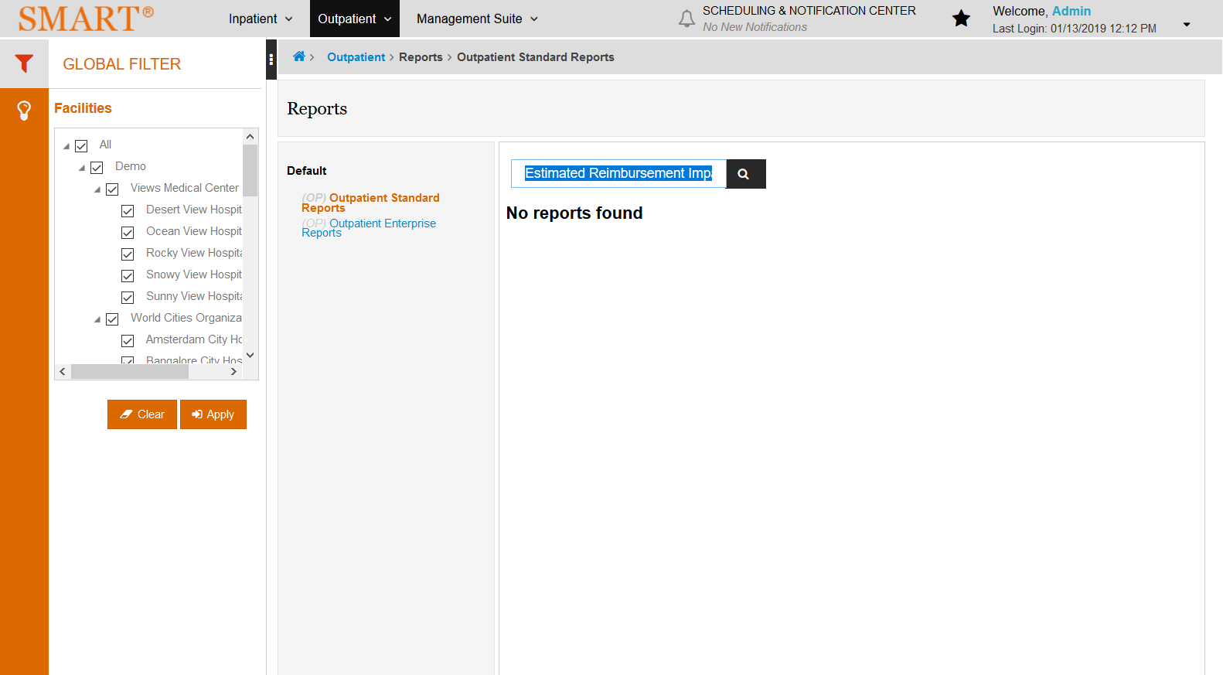

# OPSTReimbursement Change Summary: True

Test Result: Success

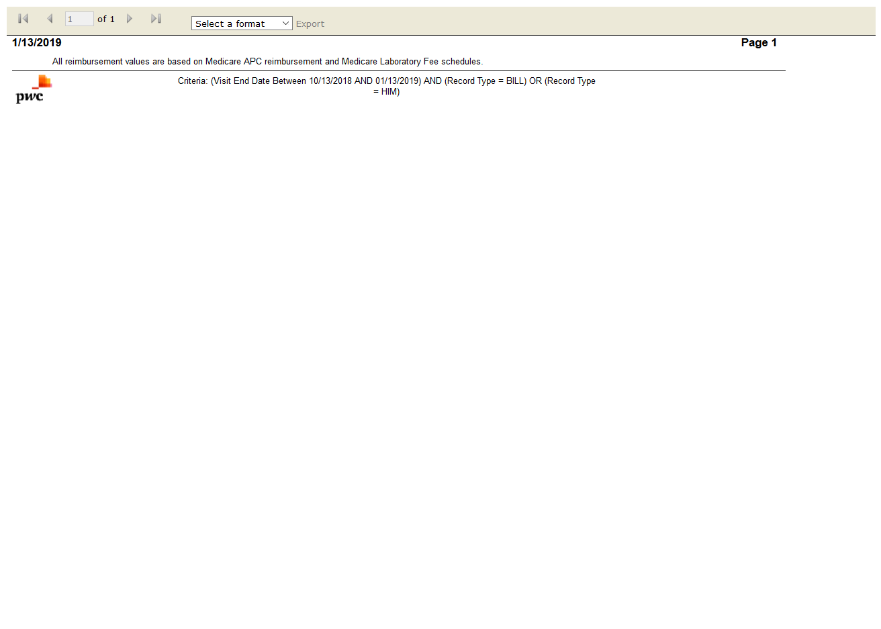

# OPSTReimbursement Version Detail: True

Test Result: Success

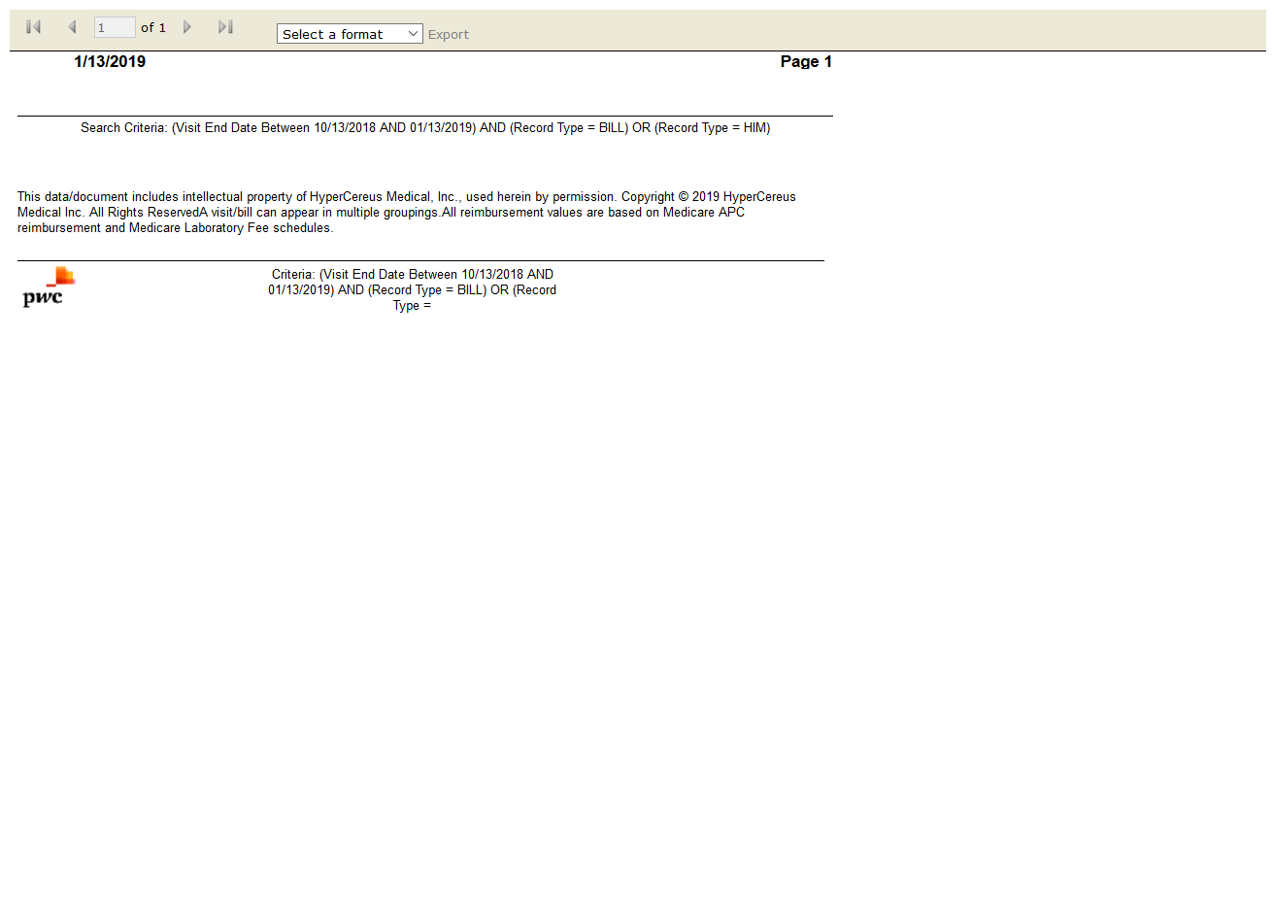

# OPSTSMART Reimbursement Activity by Year: True

Test Result: Success

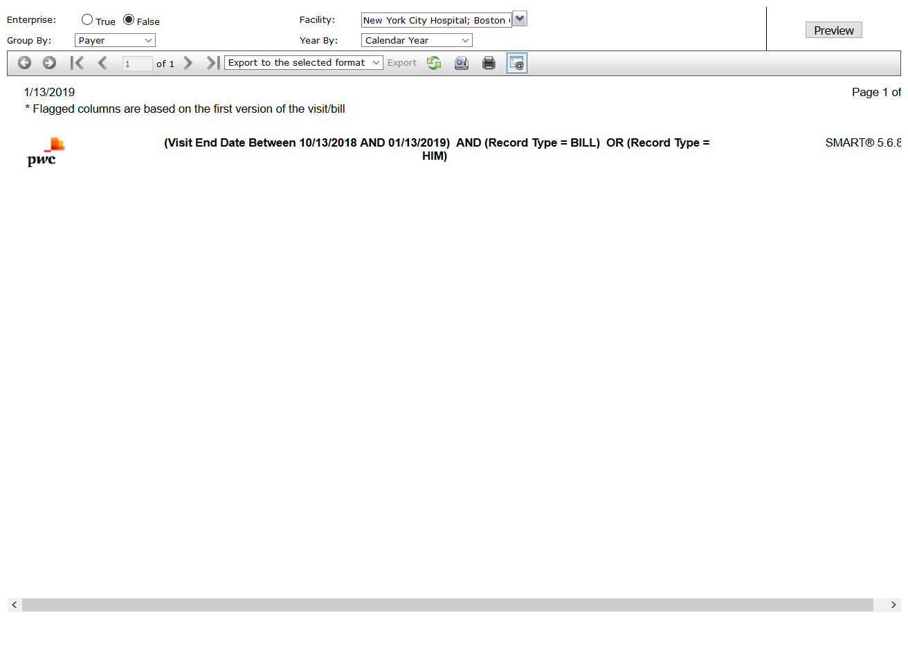

# OPSTVisit Reimbursement Summary: True

Test Result: Success

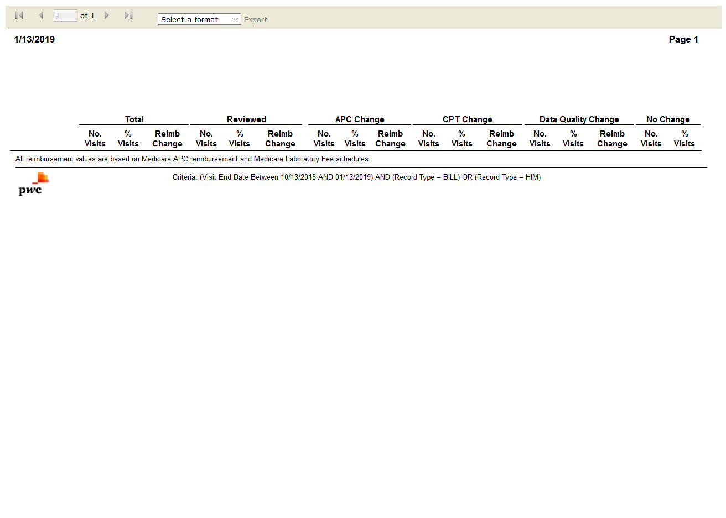

# OPSTBrief Visit Listing: True

Test Result: Success

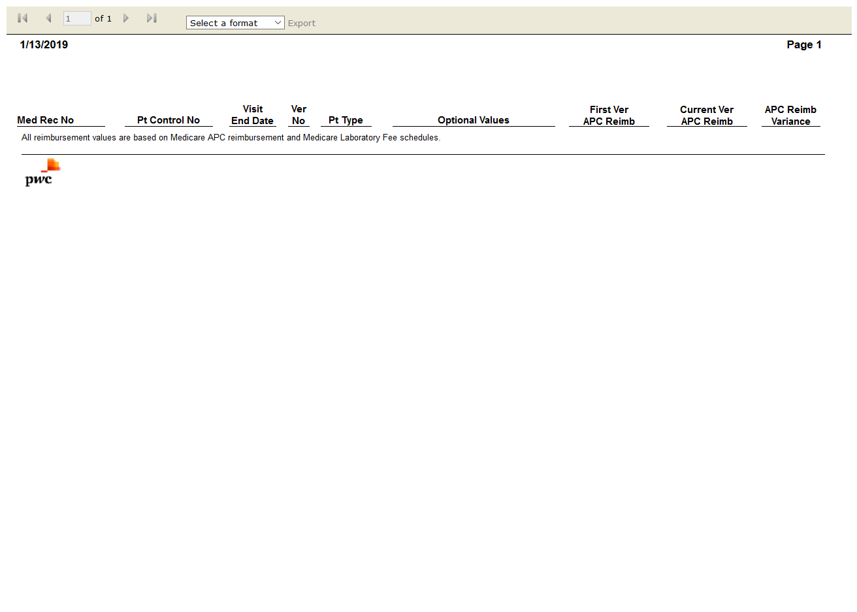

# OPSTDetailed Visit Listing: True

Test Result: Success

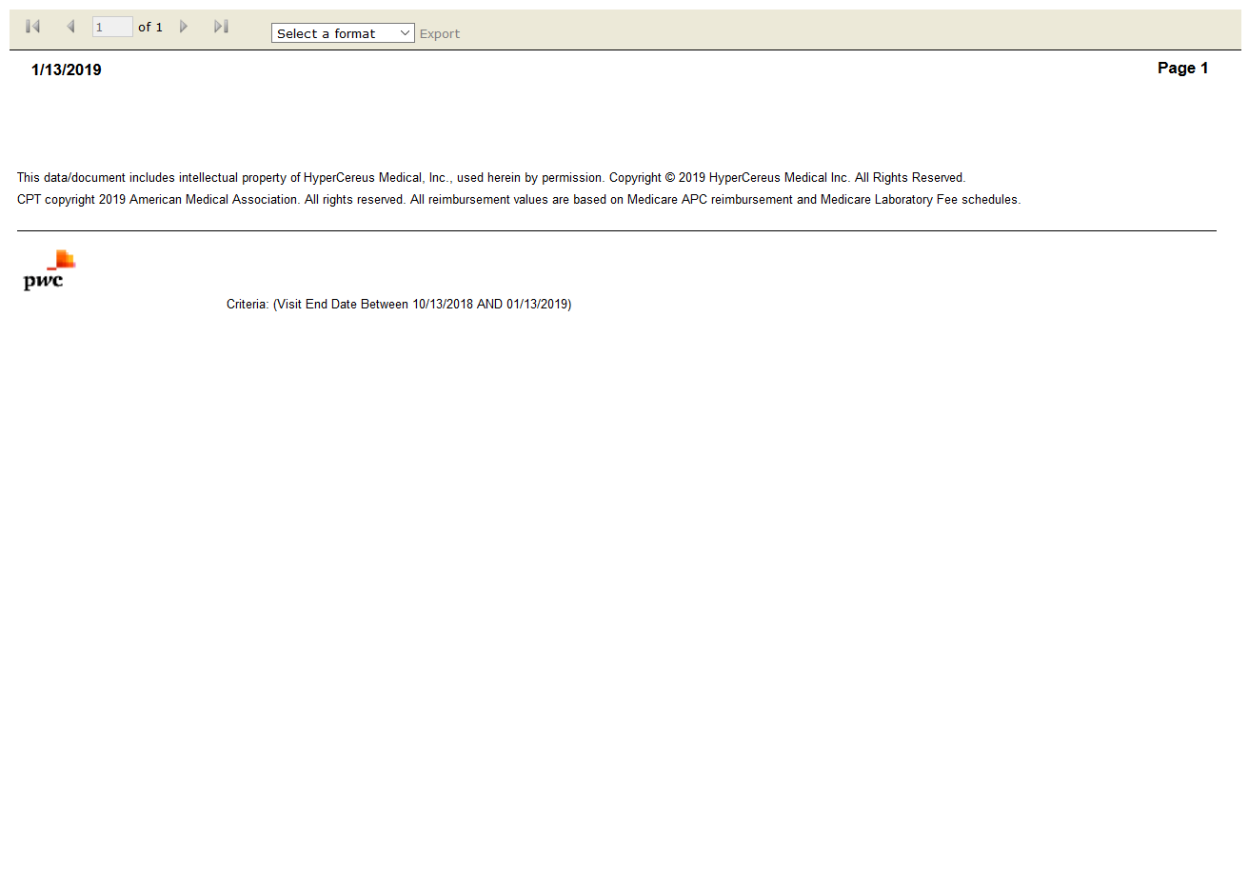

# OPENFlag Comparison: True

Test Result: Success

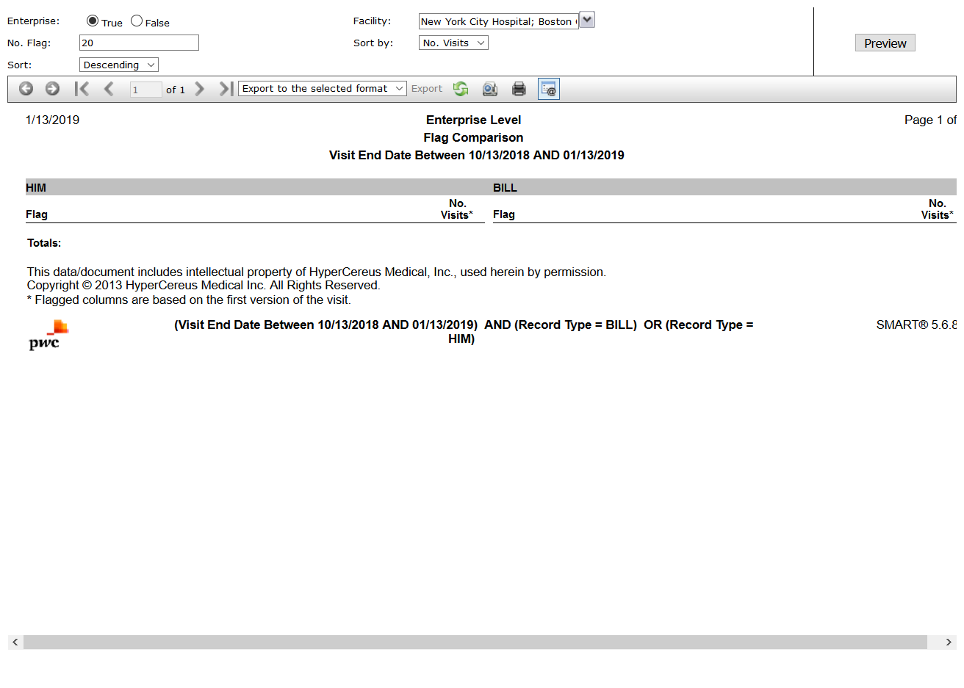

# IPSTCase Version Comparison: True

Test Result: Success

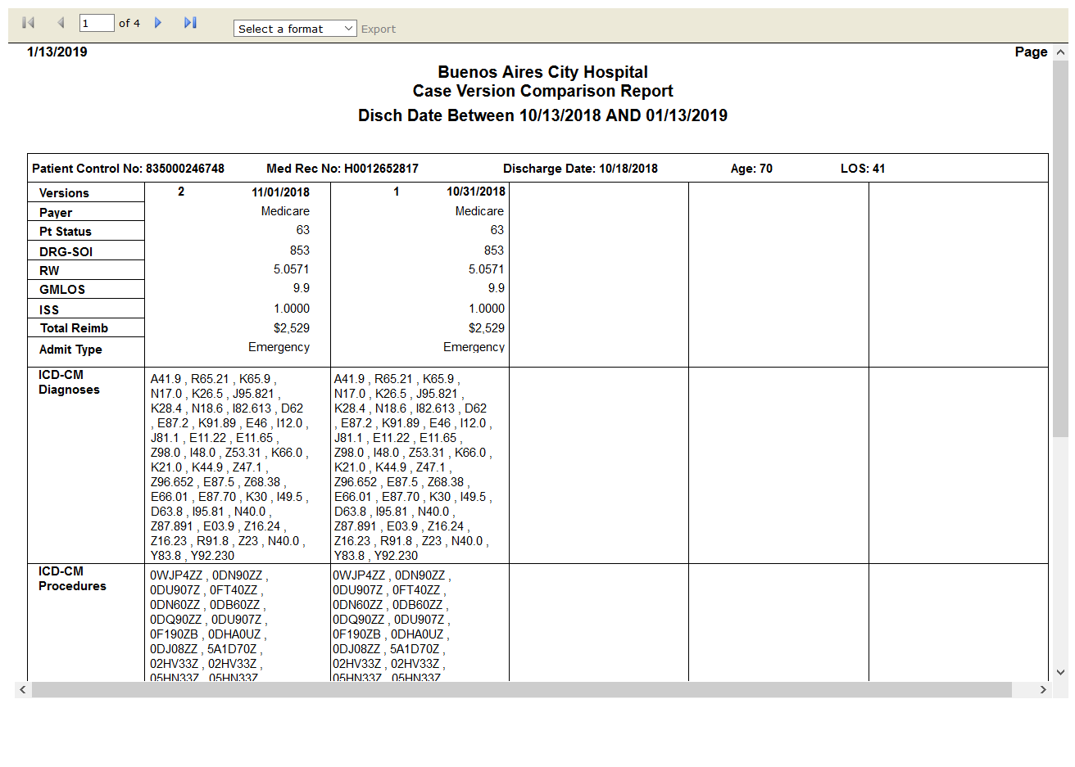

# OPENMedicare Medical Necessity Flags: True

Test Result: Success

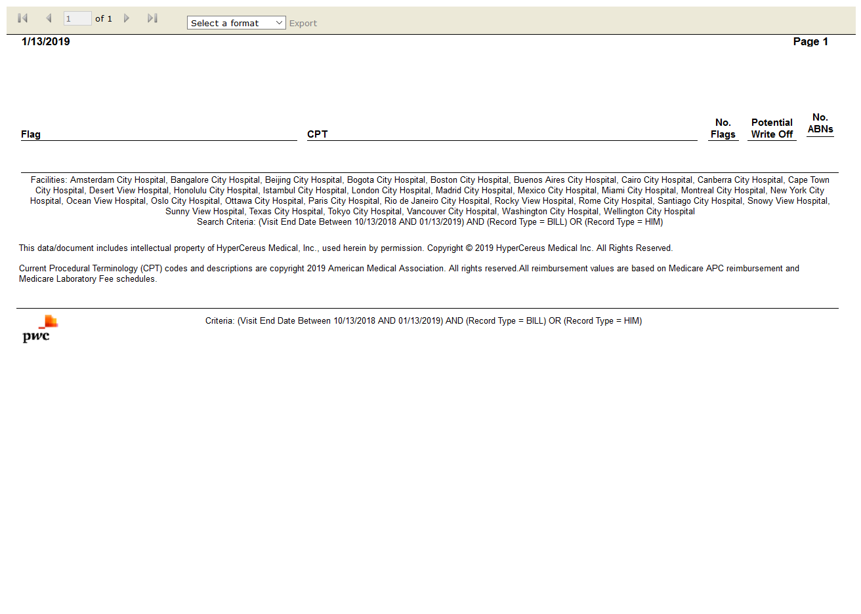

# OPENSMART Results Summary: True

Test Result: Success

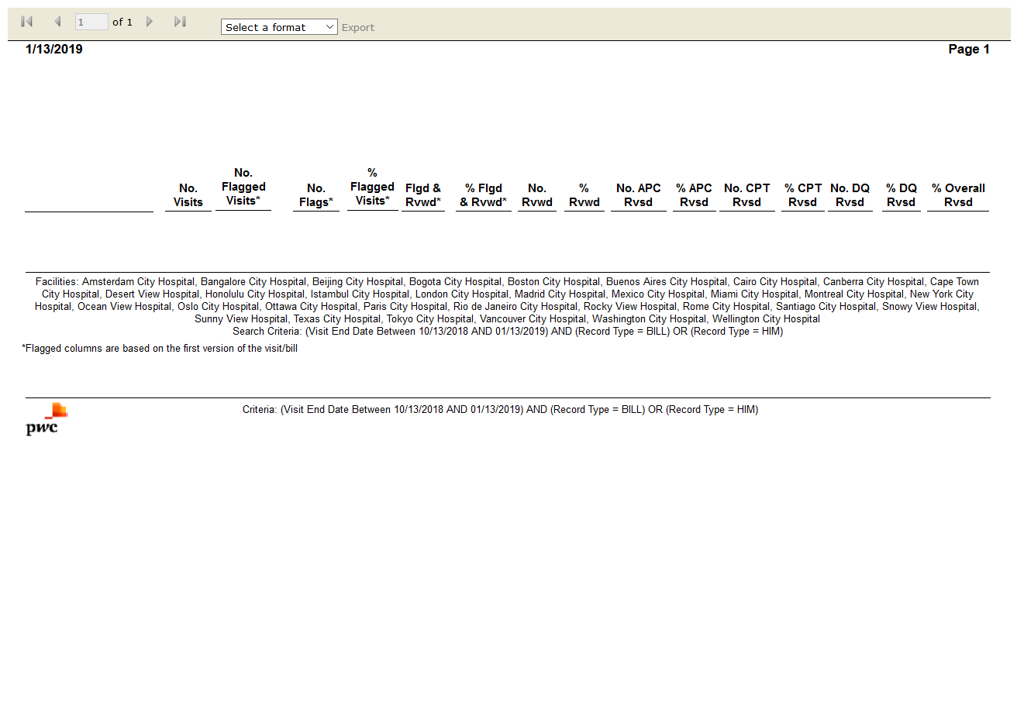

# OPENReimbursement Change Summary: True

Test Result: Success

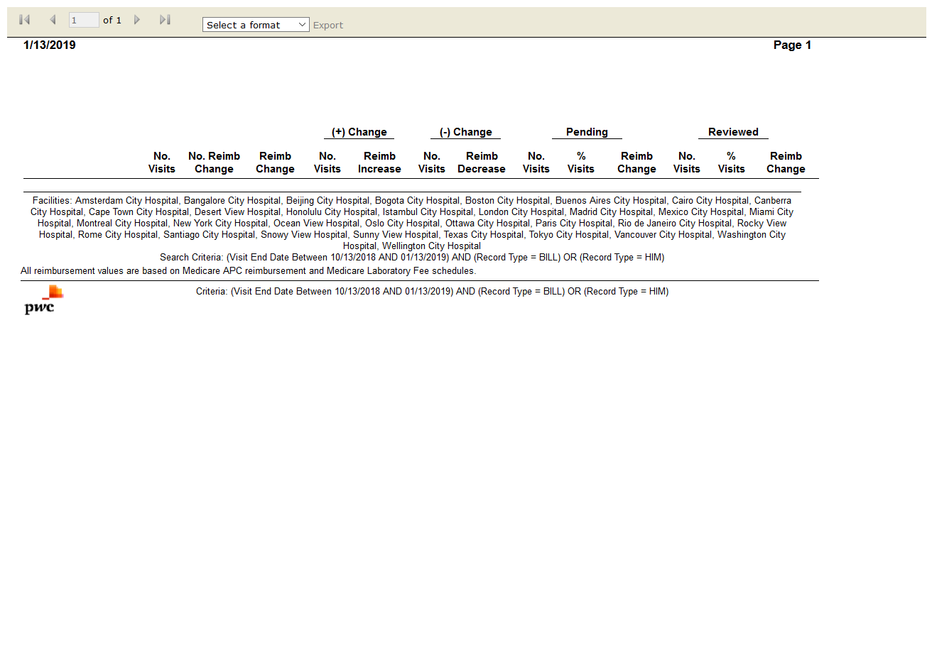

# OPENSMART Reimbursement Activity by Year: True

Test Result: Success

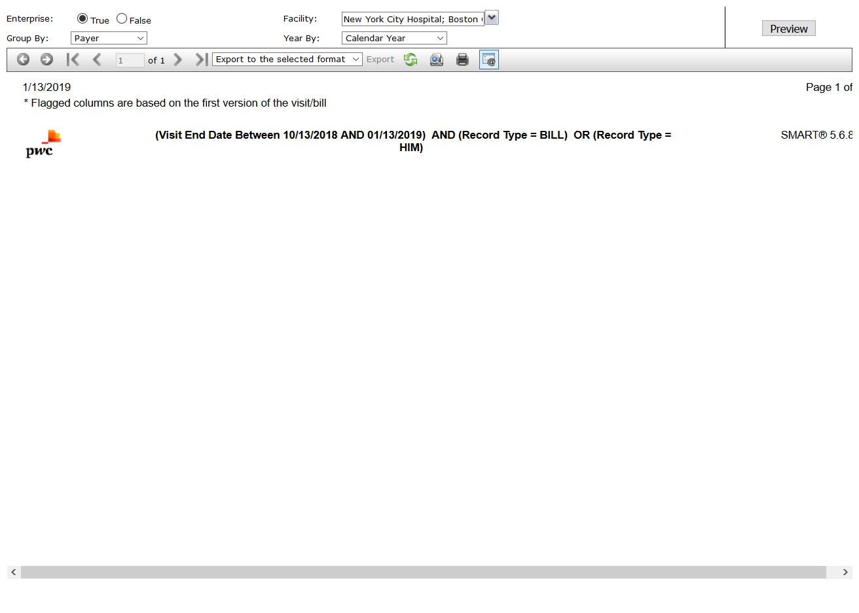

# OPENVisit Reimbursement Summary: True

Test Result: Success

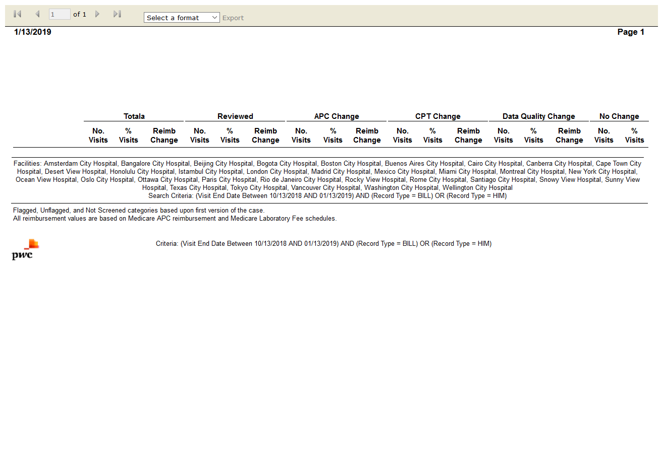

# IPSTDetailed Case Listing: True

Test Result: Success



# IPSTCase Mix Index (CMI) Analysis: True

Test Result: Success



# IPSTCase Mix Index (CMI) Comparison: True

Test Result: Success

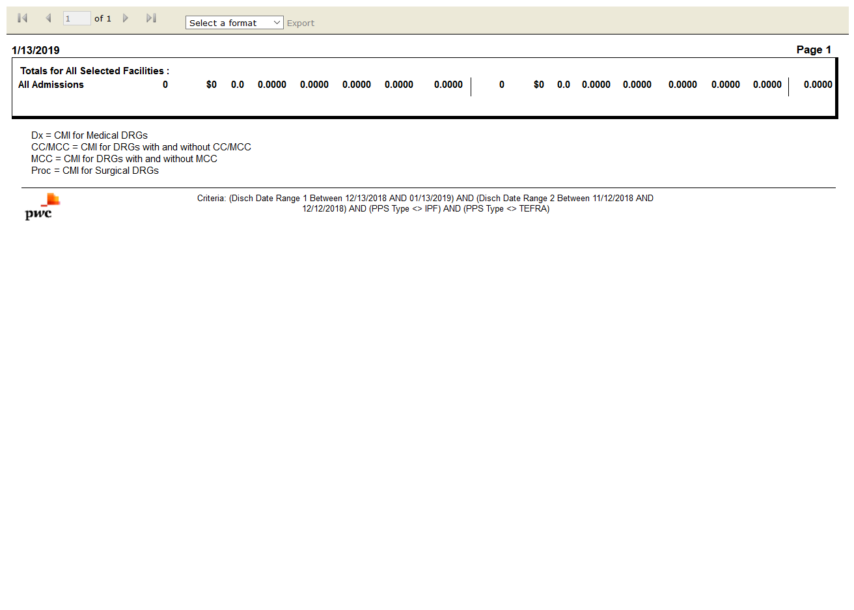

# IPSTCase-Mix by Payer by Month: True

Test Result: Success

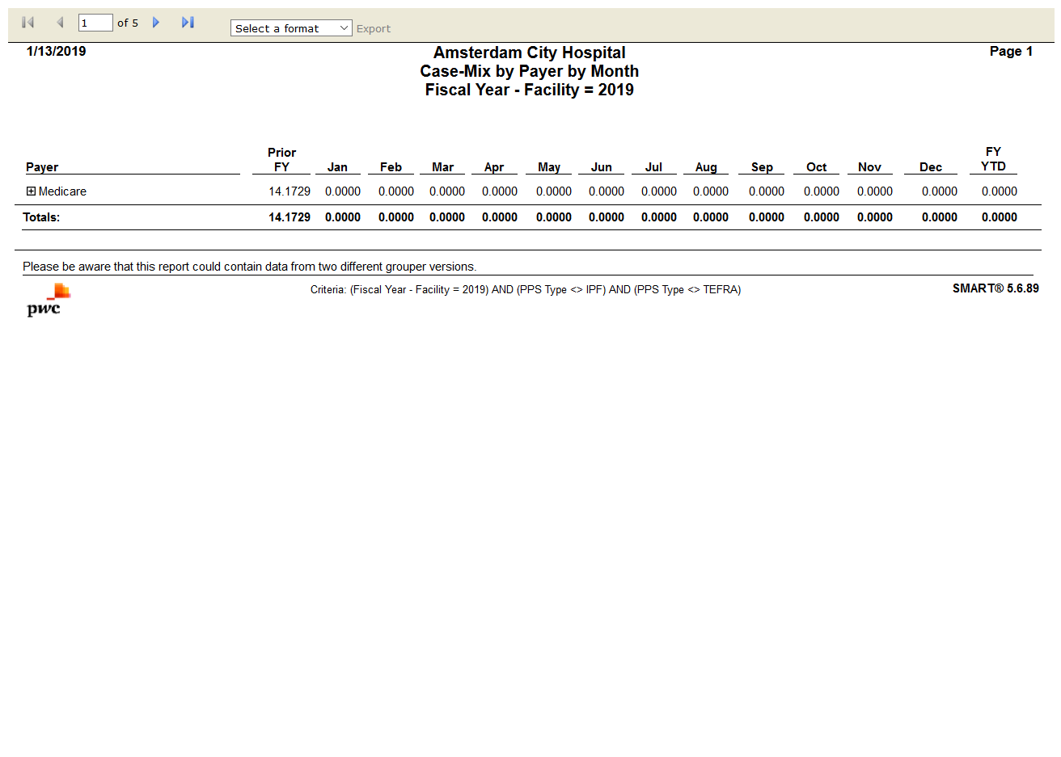

# IPSTMedicare Case-Mix by Month: True

Test Result: Success

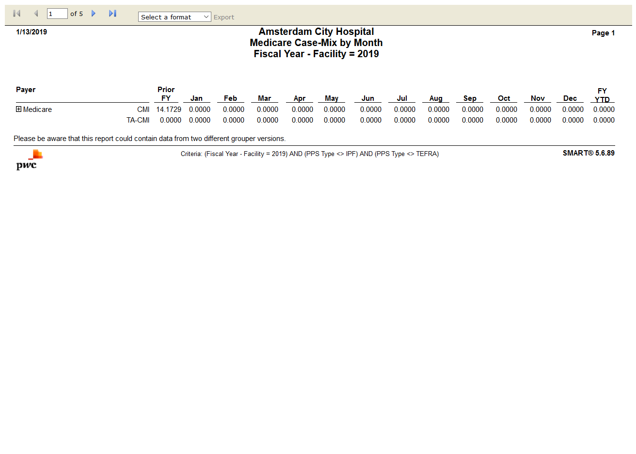

# IPSTAttending Physician Frequency by DRG: True

Test Result: Success

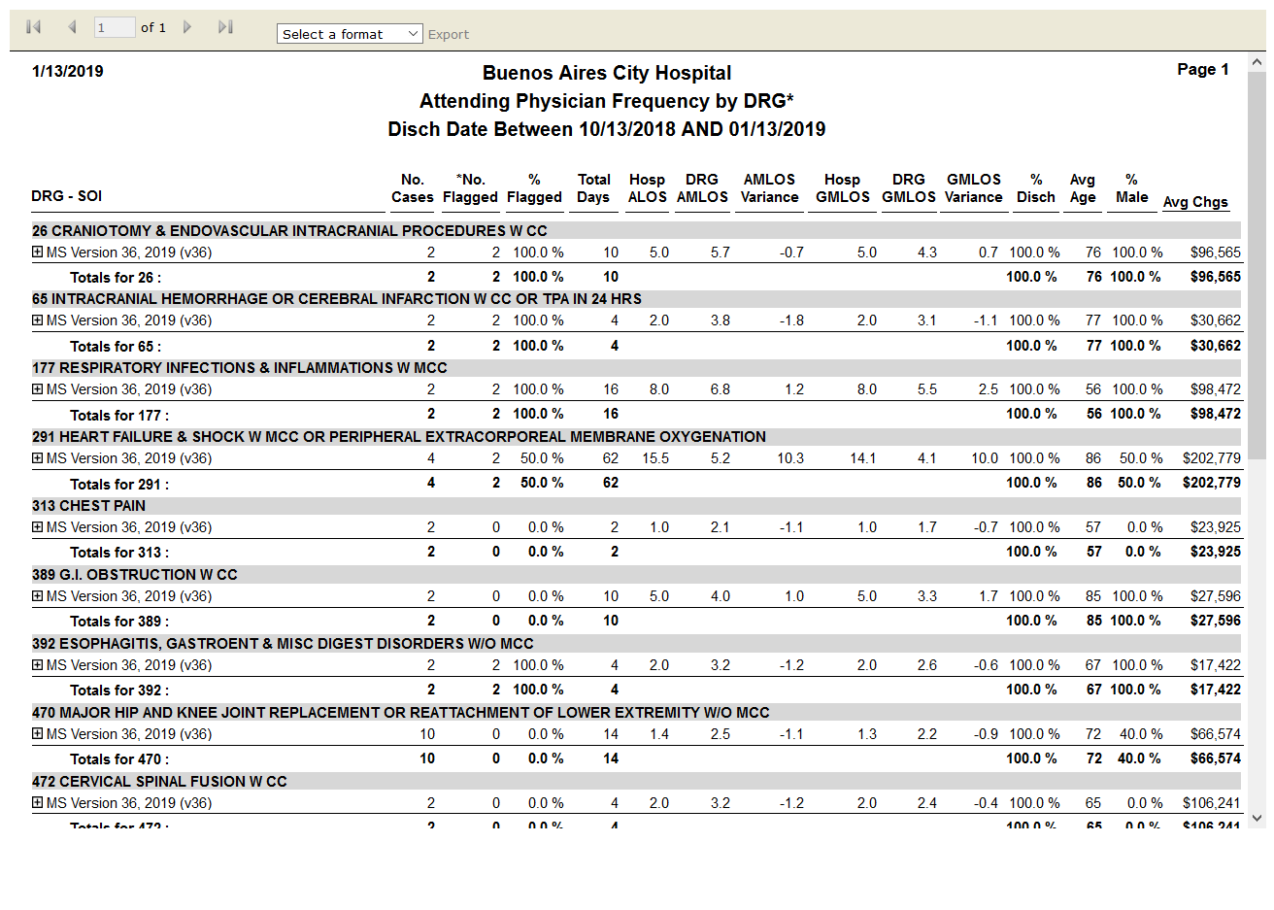

# IPSTDischarges by Grouper Version - DRG: True

Test Result: Success

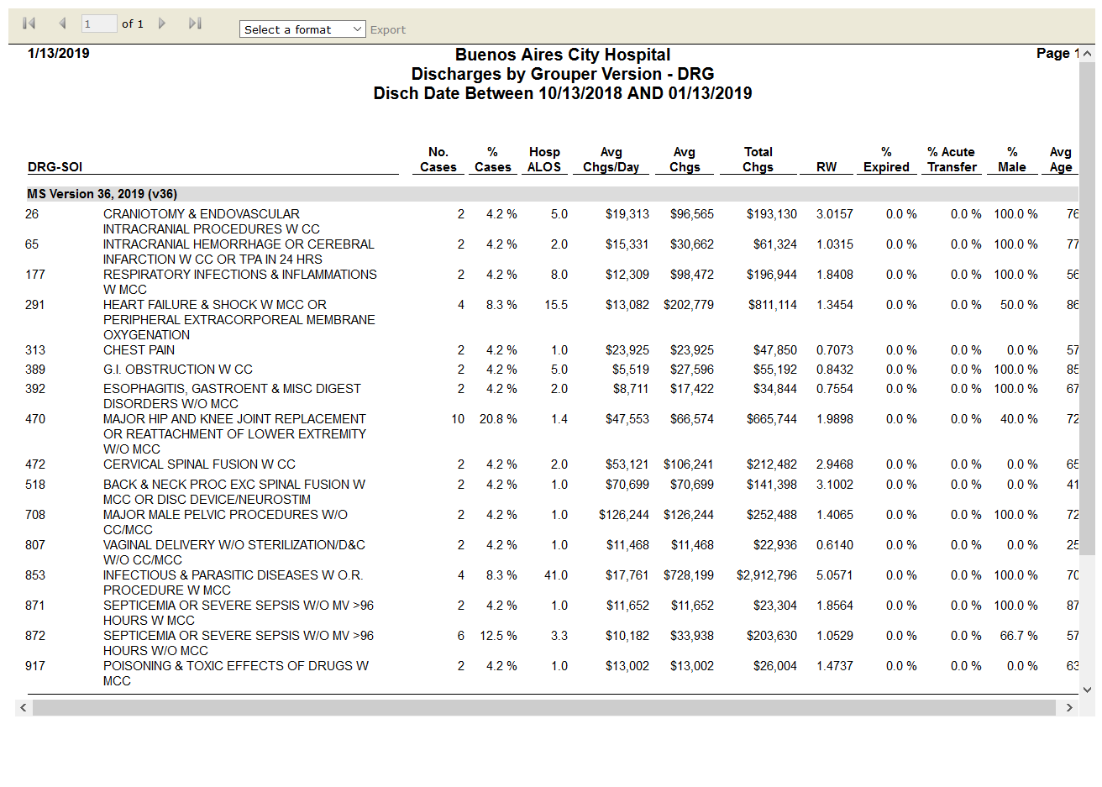

# IPSTDRG Change Condition Detail: False

Test Result: module 'common.settings' has no attribute 'error_report_generate'

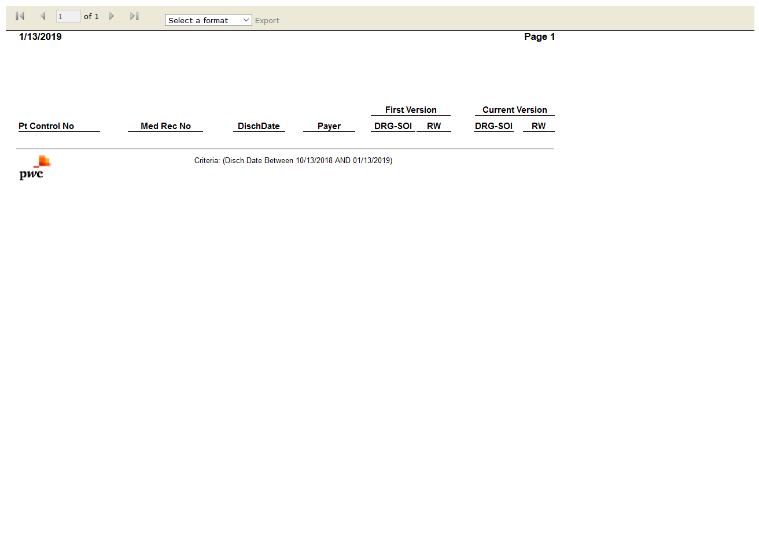

# IPSTFlag Management Setting Audit: False

Test Result: Success



# IPSTDRG Change Impact: True

Test Result: Success

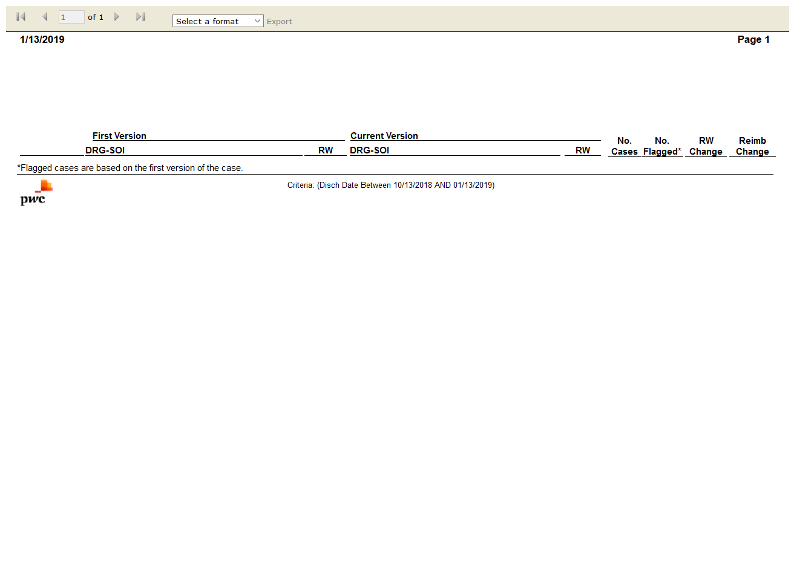

# IPSTDRG Clinical Profile: True

Test Result: Success

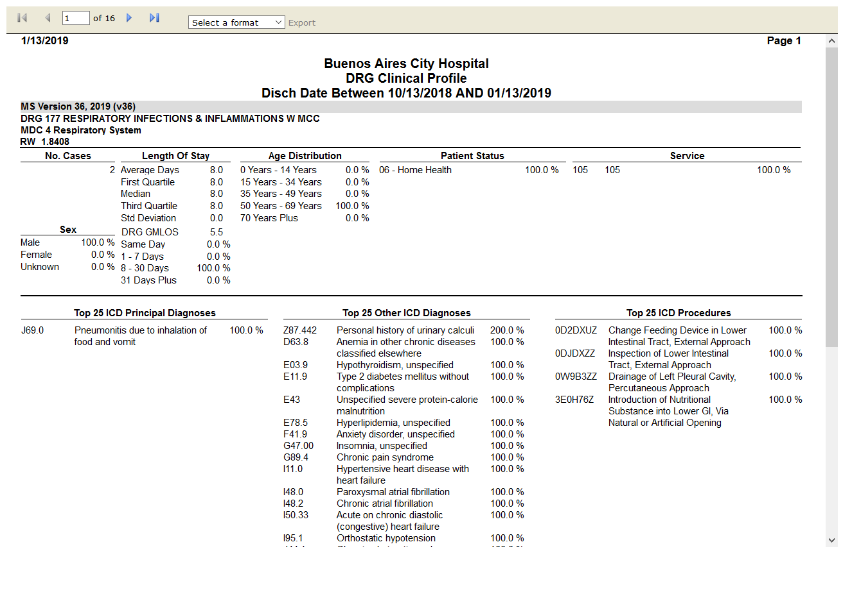

# IPSTDRG Contribution to CMI: True

Test Result: Success

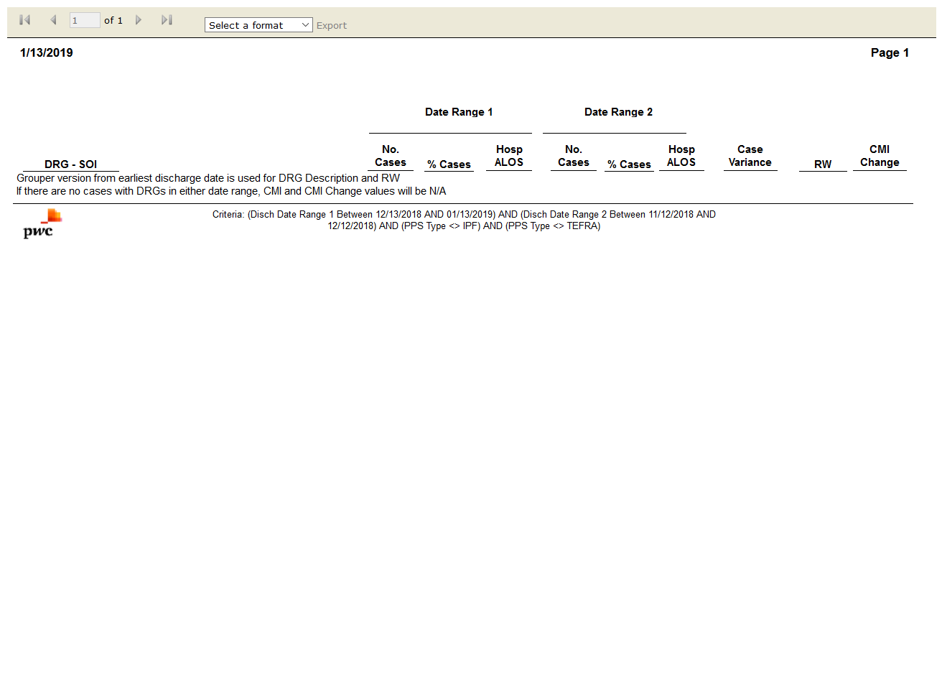

# IPSTDRG Frequency: True

Test Result: Success

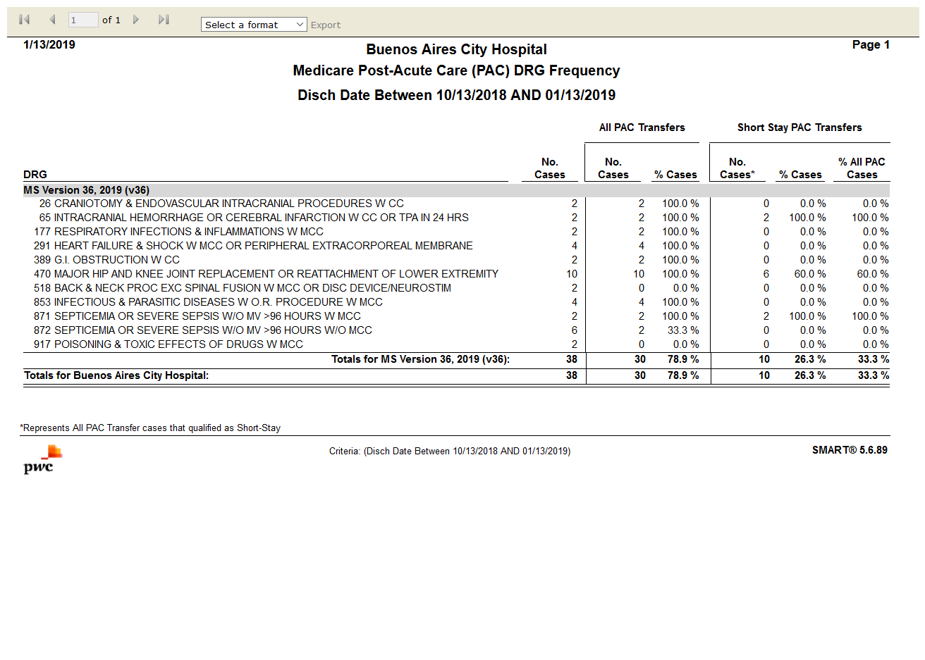

# IPSTDRG Illness Severity Score Comparison: False

Test Result: Message: Unable to locate element: DRG Illness Severity Score Comparison

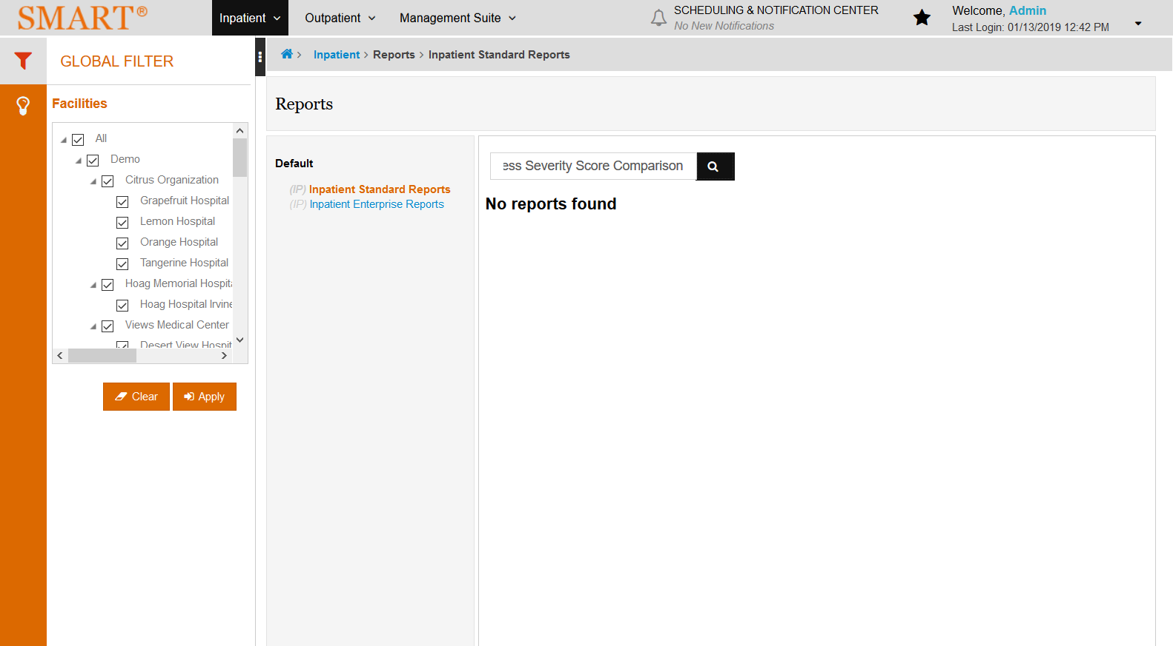

# IPSTDRG Summary by Grouper Version - MDC: True

Test Result: Success

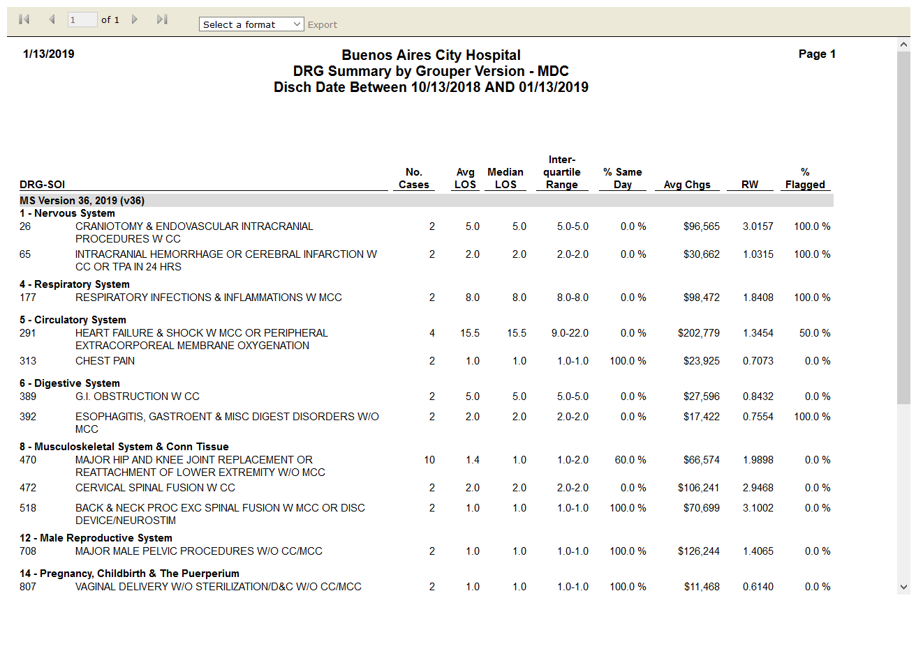

# IPSTMedicare Post-Acute Care (PAC) DRG Frequency: True

Test Result: Success



# IPSTSummary by Primary Flag: True

Test Result: Success

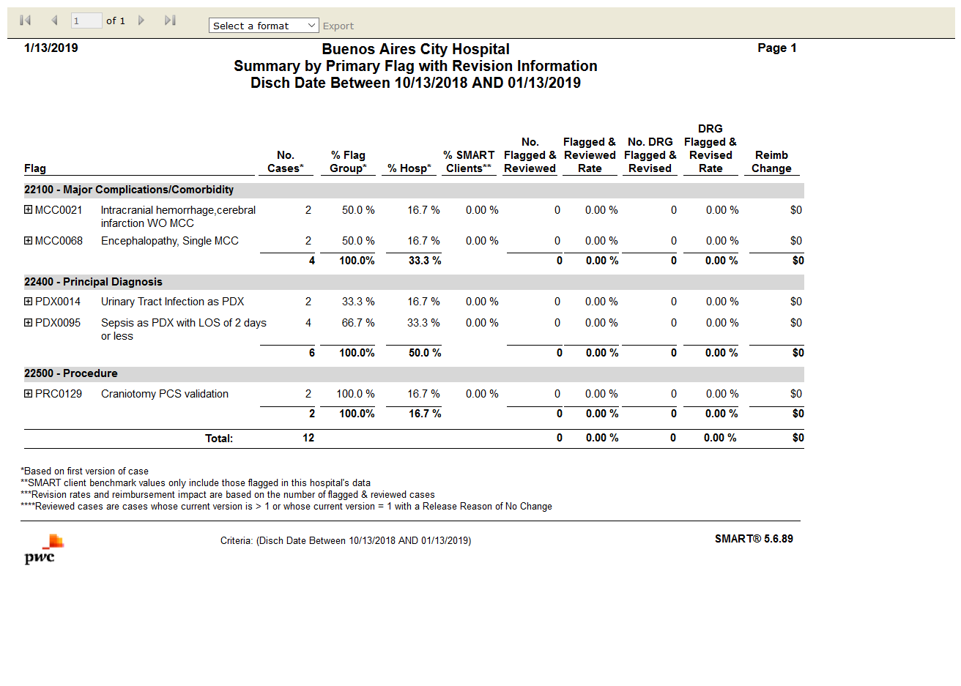

# IPSTSummary by Primary Flag with Revision Information: True

Test Result: Success



# IPSTFrequency: True

Test Result: Success

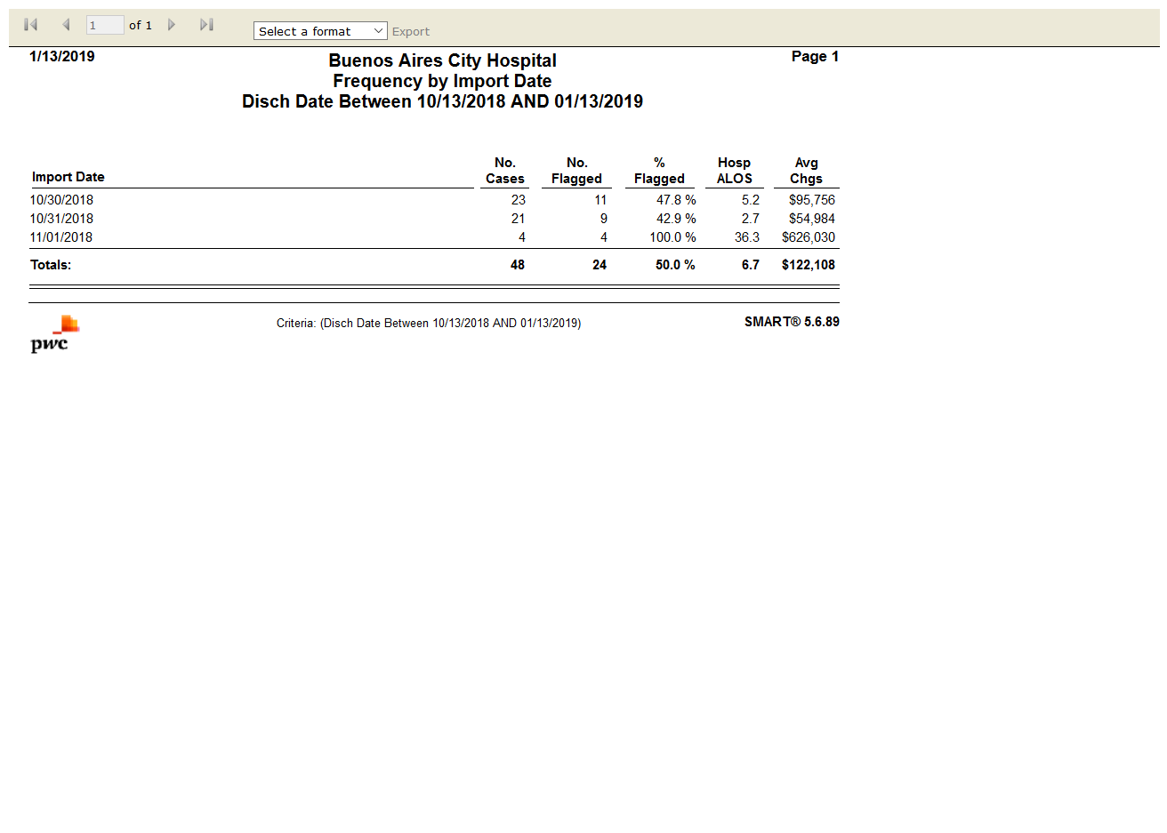

# IPSTSecurity Administration Information by Role: False

Test Result: Message: Unable to locate element: [id="aSlideMenuSelModuleSIP101"]

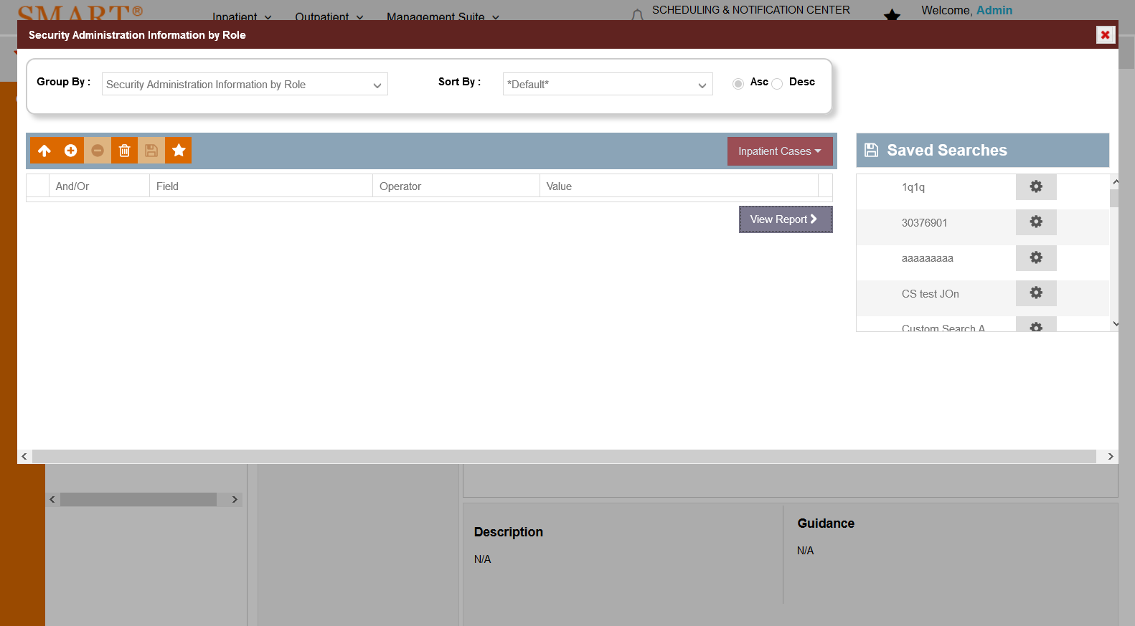

# IPSTDiagnosis Analysis by Present on Admission(POA): False

Test Result: Message: Timeout loading page after 300000ms

